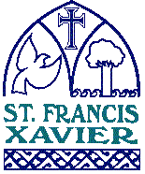

ST. FRANCIS XAVIER CATHOLIC SCHOOL
To Love, to Learn and to Serve
Kia aroha ,Kia akona, Kia aro atu

MISSION STATEMENT
Inspired by the Gospel Values, St Francis Xavier Catholic School encourages us all to have a passion for learning and serving.

CONTENTS:
Strategic Plan 2018-2023
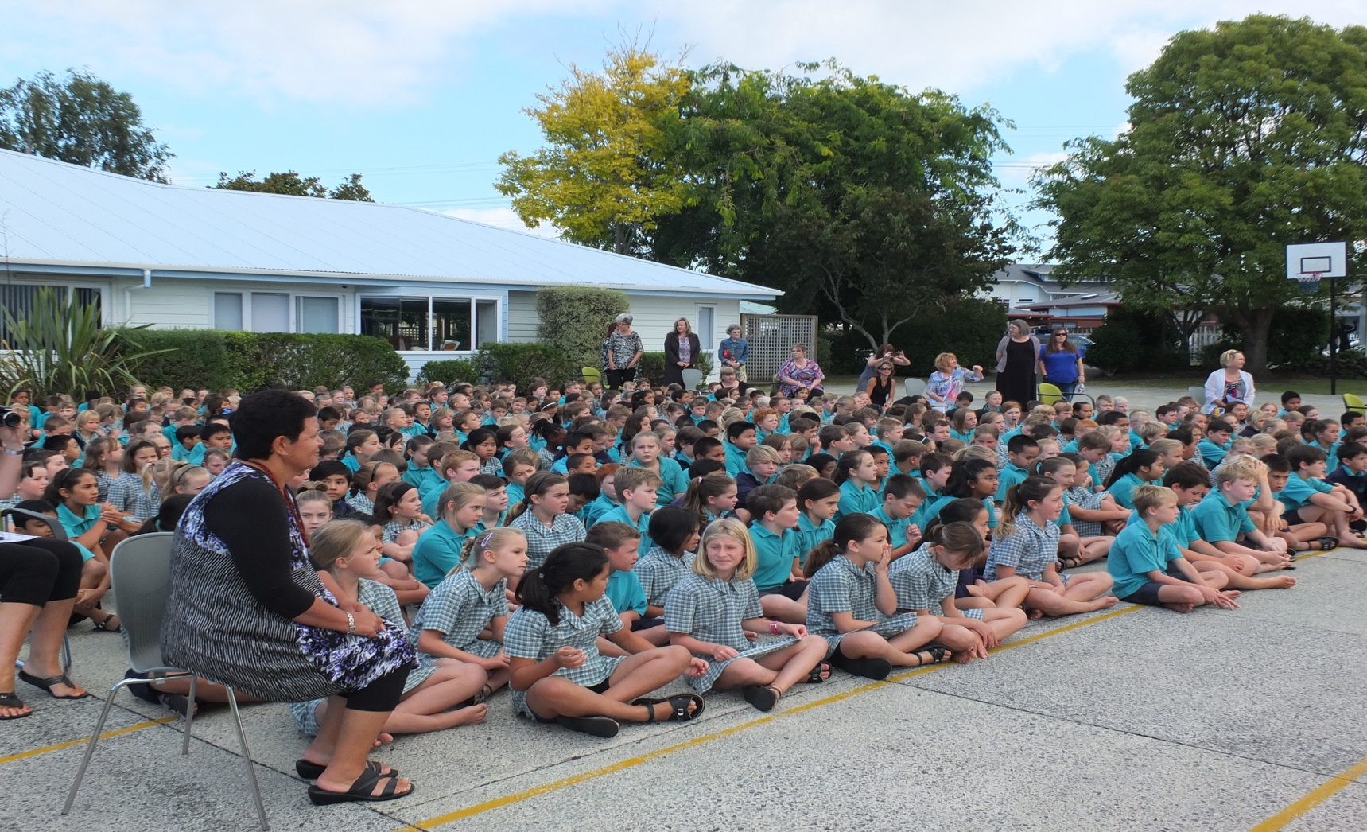
STRATEGIC PLAN
ST FRANCIS XAVIER CATHOLIC SCHOOL

MOTTO: To Love, to Learn and to Serve. Kia Aroha, Kia Akona, Kia Aro Atu.

VISION STATEMENT: Inspired by the Gospel Values, St Francis Xavier Catholic School encourages us all to have a passion for learning and serving.

We will:
- Be the first choice of school for our Catholic community.
- Be recognised for providing an education that meets the needs of each individual.
- Strive for academic excellence.
- Resource our school with appropriate information technologies.
- Be at the cutting edge of educational development.
- Ensure that the staff is well-supported and proud to work at the school

The Teaching Framework:
The school is a Roman Catholic Primary School, in which the whole school community, through the general school programme and in its religious instructions and observances, exercises the right to live and teach the values of Jesus Christ. In order to achieve this we will:
- Create a moral climate in our school / classrooms that will promote and teach the values of Jesus Christ.
- Integrate the Religious Education programme with the curriculum.
- Develop a learning environment in our classrooms that will recognise effort and demonstrate curriculum immersion.
- Base our teaching on recognising the importance of every child’s individual needs.
- Provide a range of learning experiences based on the seven essential learning areas plus Religious Education.
- Believe that all students can learn if they are motivated and receive appropriate help and guidance.
- Utilise the human resources within our community, to promote partnership in learning.
- Consult with parents and caregivers at regular intervals to inform, share and develop a learning partnership.
- Work in partnership with whanau, to raise the level of achievement of Maori students.

Goals: “What the school has to focus on in terms of its vision.”
- To provide a safe, happy and challenging environment that embraces the Catholic character.
- To promote strong links between home, school, Parish, whanau and the wider community.
- To continue to foster important relationships between the Parish and the school.
- To identify and enhance children’s individual learning skills spiritually, academically, socially, physically and emotionally.
- To promote an education which values cultural difference and understanding.
- To encourage academic achievement and life long learning skills.
- To network with local agencies to enhance educational opportunities.
- To network with Catholic schools in our Diocese.
- To ensure that the school’s programmes reflect the areas Catholic historical and cultural heritage.

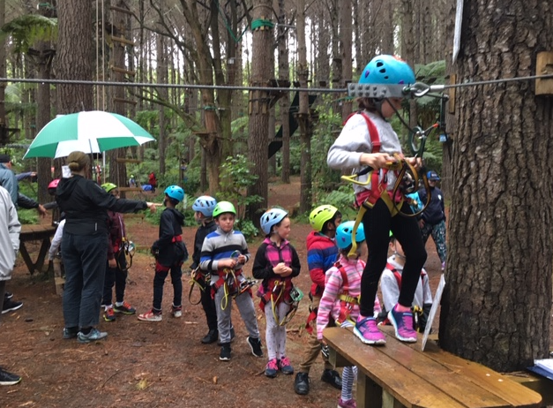

STRATEGIC PLAN

2020 – 2023

“In order that the Catholic school and the Catholic teachers may truly make their irreplaceable contribution to the Church and to the world, the goal of Catholic education itself must be crystal clear. Beloved sons and daughters of the Catholic Church, brothers and sisters in faith: Catholic education is above all a question of communicating Christ, of helping to form Christ in the lives of others.”
Pope John Paul II

 | SCHOOL CONTEXT
Special Character | We will review and report on our school’s Special Character to ensure that the school continues to create a Christ-centred school that will promote and teach the Gospel Values.
School Profile | The school has an opening roll of 473 students and it is anticipated that this will increase to 540 by the end of 2022. The roll has steadily increased over the past few years.  Year 07 08 09 10 11 12 13 14 15 16 18 19 2020 21 22  Roll 407 438 449 453 437 457 454 444 462 478 485 463 479 475 473
School Organisation | The school Principal is released to lead and manage the school. He is also a shared Kāhui Ako (CoL) leader and is therefore released from the school for one day a week to lead the CoL. Two Deputy Principals, who are also released from teaching a regular class of students, ably support him. The DPs undertake the teaching of individual and groups of students, they also release, coach and mentor colleagues, supervise the Special Needs programmes, lead the curriculum and offer pastoral support. The school has a Director of Religious Studies who oversees the implementation and teaching of the Religious Education programme. There are five Whanau Leaders who lead teams of three to four teachers. The school is organized into Whanau (family) groupings and there are composite classes in Years 3/4 and 5/6.
Review of Policy, Programmes,  Charter and Strategic Direction. | - The school leadership team, Board of Trustees and staff regularly consult the parent community.  - Each year the Auckland Diocese requires a record of consultation about a particular aspect of the Religious Education curriculum.  - The Board of Trustees and Staff worked to establish a new strategic direction for 2018 – 2021. The plan has been further extended to 2023 with the same objectives in mind. Consultation and a Teacher Only Day resulted in the plan below. The plan has been amended to include the new National Education Priorities. The parent community was invited to read, have input and comment on the Strategic Plan.  - Through the Mapping approach to curriculum delivery the Mapping Team and teachers review curriculum programmes each term.  - School wide policies are reviewed by the Board of Trustees in a timely manner. The Board is currently transferring policies to SchoolDoc.

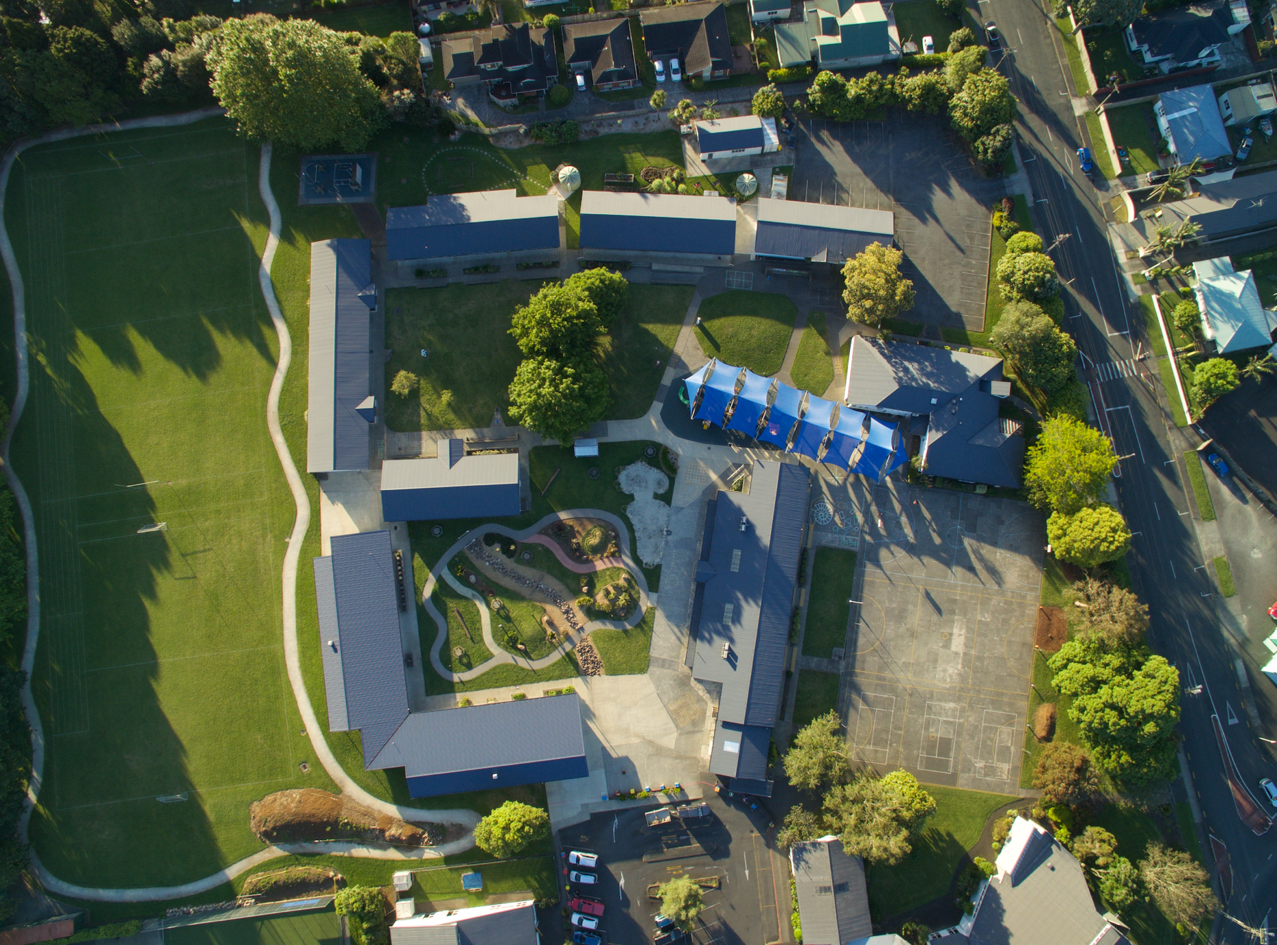

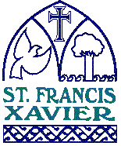 ST FRANCIS XAVIER SCHOOL ANNUAL PLAN 2022

There are two specific goals in 2022.
- To re-engage our learners and their whanau by focussing on their wellbeing after Covid interruptions.
- To respond to the results of a schoolwide survey. The emphasis being on “culture”

STRATEGIC GOAL – UNITING THROUGH CHRIST  The Catholic school has as its aim the critical communication of human culture and the total formation of the individual. | STRATEGIES FOR ACHIEVING THE GOAL | PROGRESS INDICATORS | 2022 ACTION PLAN
- To affirm our Special Character.  - To develop a Christ centred Catholic community.  - To teach and live the school Catholic values, including tolerance, love, respect, relationships and humanity for all.  - To uphold our bicultural and then our multicultural partnerships. | Ensure that teachers receive Religious Education professional development.  Include Catholic character expectations in all job descriptions.  Review dimensions of the Special Catholic Character Review and Development document.  Receive a positive review from the Catholic Education Office.  To develop strategies that will draw parents and children into active participation in parish life.  Communicate to parents what it means to enrol and have your child attend a Catholic school.  Maintain an ethos that all staff, ancillary, support and teaching are treated equally and with dignity.  Through a Christ centred school we will live and teach Catholic values.  To continue to build and develop relationships with our bicultural and multicultural communities.  To improve equity and increase levels of achievement of our priority learners. | Teachers receive at least 12 hours per annum of RE professional development.  Annual budget to provide for Special Character and RE professional development. Special Character goal to be included in appraisals (PGC)  Teachers wishing to gain further qualifications are to be supported. This personal goal will form part of their PDP (appraisal).  Job descriptions to reflect Special Character.  Catholic Character Review recommendations to be actioned and monitored via monthly reports to the Board of Trustee Special Character Subcommittee  Children demonstrate and practice knowledge of their Catholic faith by participation in school mass, liturgies, the reciting of prayers.  Children respect and follow the values, attitudes and beliefs that the school holds by observing and living our school motto “to love, to learn and to serve. Kia Aroha, Kia Akona, Kia Aro-Atu” These qualities are reinforced in school assembly, school activities in the classroom and modelled by all staff.  Regular reviews of existing practices are monitored and improvement plans developed e.g. Whanau Mass, school Mass, Baptism programme.  During He Kakano (New Entrant transition programme) meetings, explain to parents the role that they need to play in supporting our Special Character and Catholic faith.  Act on new initiatives and monitor / report on progress to the Special Character sub committee.  Provide plans and show communication that continues to promote Family Mass, liturgies, school Baptism and transition programmes.  Staff are valued and supported in their work – feedback via surveys, team meetings and appraisal.  The school vision of “Uniting through Christ, embracing mana and enhancing futures” is understood and verbalised by the community.  Consultation, communication is evident at every level within the school. Fortnightly newsletters, PTFA meetings. Parent / pupil triadic meetings held in Term 1 and Term 4 He Kakano.  The mission of the Church is upheld.  Ensure school wide concepts promote a Catholic worldview.  Kapa Haka is available to all Year 5 and 6 students and Year 4 students depending on the demand and availability of the tutor each year.  Consultation with the whanau of priority students will be fostered by communication with families.  Reducing disparity – through achievement data that identifies target groups and priority learners  Principal to consult with different ethnicities. (eg Filipino and Pacifica)  Continue ESOL programme for English as second language speaking children.  Tika (doing the right thing), pono (truth, honesty and integrity) and aroha (love, compassion, empathy) the fundamentals of Maoritanga are underpinned by Whanau Meetings, PTFA , classroom expectations and curriculum delivery. | The Diocese is waiving the 12 hour requirement for 2022.  Teachers wishing to undertake RE Instruction and PD will be supported to do so. The PD budget prioritizes this.  Completed. Job descriptions for new employees to include the RE documentation.  Ongoing. The motto is discussed with parents at the He Kakano sessions so that the message is reinforced at home.  The motto is regularly referred to in school, year group and whanau gatherings.  Due to Covid Phase 2 requirements some of this work has been halted.  Mrs Glenys Jakicevich undertakes this job as part of the He Kakano sessions.  The RE Special Character team will report to the Board on the mentioned activities. Eg Summertime Mass.  7-10 year old students will be encouraged into baptism. Five Sunday whanau masses will be part of our commitment to the Catholic community. Children are encouraged to be involved in Mass and take part with roles such as altar serving and reading the readings.  The school continues to be a part of the Kāhui Ako Hub. The work undertaken has a strong emphasis on Wellbeing and these practices supplement our Special Character.  Wellbeing survey results indicate that there is still room for improvement. The Wellbeing group will review the findings from surveys and put forward some new ideas.  In 2022 and because we are operating in the Red zone, the “Meet and Greet” session will be replaced by zoom and phone contact at the request of the parent.  A significant goal for us in 2022 is to ensure that the wellbeing needs of staff, students and whanau are being met and supported.  Learning Support Co-ordinator and Family Worker have an integral role to play here.  Whanau Leaders will feedback on Priority Learners each term.  These indicators are largely embedded in our self-review process. Continual attention to the goals and an awareness of changes is essential to monitor effectiveness.  An area that needs to be developed is the consultation with the various ethnicities. Large group meetings do not achieve the benefits as face to face 1:1 discussion. The principal and leadership team are aware of this and are endeavouring to make more regular contact with parents from other ethnicities.

STRATEGIC GOAL - EMBRACING MANA  Catholic education recognizes and affirms all cultures and ethnic groups especially those represented within the school community. | STRATEGIES FOR ACHIEVING THE GOAL | PROGRESS INDICATORS | 2022 ACTION PLAN
- To respect each individual’s mana regardless of their culture, ability or gender and treat them with dignity  - To act with independence  - To improve individuals’ self worth and develop their strengths.  - To create enthusiastic, resilient and successful students so that they can succeed in life. | To know our learners, their stories and their aspirations  Develop respect for their own and others’ culture and heritage giving priority to Maori language and culture.  Be culturally responsive to the needs and aspirations of Maori learners, their whanau, hapu and iwi.  Foster inclusive practices for all.  Develop strengths and passion through creative and innovative teaching strategies.  Encourage independence and develop a “Can do” attitude to learning.  Provide support guidance and pastoral care.  Offer opportunities for whanau group activities and tuakana teina relationships.  Continue to provide programmes to assist ALL children to achieve.  Promote a healthy lifestyle.  Recognise and strengthen each individual’s self esteem.  Look for opportunities to celebrate success. | Opportunities for sharing cultural identity.  Sharing children’s voice and narratives by the curating of school wide concepts..  Identifying iwi and hapu affiliation of students at enrolment.  If resources are available, respond to parent requests for te reo Maori.  Seek opportunities for children to experience another culture through programmes like kapa haka and puna reo dependant on numbers. Consideration given to Maori identifying hapu or iwi affiliation.  Liaise closely with the whanau group and parents of Maori students through meetings and parent communication.  Identify ways to engage with the whanau of priority learners to seek opportunities of support from others.  Increase student agency. (The level of autonomy, power and control that a child experiences in a learning situation) by understanding their next learning steps and constructing these with parent, teacher and child.  Designing programmes to enhance learning experiences across the curriculum.  Identify strategies to enable children to share their learning by encouraging children to “have a go”. Success measured through pupil surveys and student voice.  Subject to finance, continue to employ a Family Worker.  Show compassion, support and understanding in keeping with the school’s Special Character.  Seek and support opportunities for school wide leadership .  Support pupil learning with remedial and extension learning opportunities.  If budget permits, introduce the Employment Assistance Programme. (EAP)  Through curriculum concepts develop opportunities to promote health and wellbeing.  Implement strategies and recommendations from the New Zealand Institute of Wellbeing and Resilience.  Promote and celebrate student academic and sporting success through the sharing of more information in the school newsletter, web site, or other forms of communication | Term 1and 2. Emphasis on this goal.  Provide support for students, staff and whanau experiencing difficulty with Covid related matters.  Undertaken and now part of enrolment procedure.  In 2018 the kapa haka programme was extended to include Year 3/4 pupils. This was a good initiative and one that we would like to embed in 2022.  Meetings to be held as the need arises or in preparation for a significant event.  One of the tasks of our Family Worker is to foster relationships with whanau and school. Regular meetings with DPs and principal to develop case load.  Build on last year’s initiatives and develop STEAM. Research successful interventions, review possibilities, set up resources, staffing.  Could form part of a wellbeing strategy to develop independence.  Children to work on their strengths. This is an opportunity to children to grow, not an opportunity to highlight what they don’t know. It is also an opportunity to learn from mistakes, experiment and open eyes to their potential.  Ongoing. Funding continues to be sought from the Catholic Caring Foundation. This programme is going from strength to strength.  Implement changes to the selection and organisation of student whanau leaders. New roles and appointment by March 2022.  Subject to funding and staffing.  Implemented February 2019. To be reviewed in 2022.  To address areas for development as identified in the school wellbeing survey.  Work with the Hub to deliver the Wellbeing Achievement Challenge.  Appoint Across School Teacher for Wellbeing. Begin work with Denise Quinlan.  A small committee will feedback to teachers and children ways to “feel good and function well”

STRATEGIC GOAL – ENHANCING FUTURES  Catholic schools encourage students to become aware of their responsibilities as citizens of the world. | STRATEGIES FOR ACHIEVING THE GOAL | PROGRESS INDICATORS | 2022 ACTION PLAN
- Enable children to achieve academic excellence and provide tools to enhance innovative thinking and creative problem solving.  - To develop children so they will have the skills to make a valuable contribution to our society, communities and global communities.  - To give children skills so that they can develop emotionally, physically, spiritually and socially  - To empower children to be the next generation of guardians for the world’s environment. Kaitiakitanga. | Maintain access to ICT that supports student learning.  Increase understanding and access to technology to better support technological development in the future.  Provide a high quality education that promotes excellence and lifelong learning skills.  Ensure that the Key Competencies are an integral part of every child’s learning.  Help educate parents so that they can better support children’s learning  The school will offer a balanced curriculum enhancing all aspects of a child’s development.  Provide a safe learning environment  Provide support and guidance.  Liaise with outside agencies to support students and parents.  Provide opportunities for parents to socialize and develop relationships with others.  Look for opportunities to educate children about the need for conservation and sustainability. | Build on existing devices and consider BYO options by developing a strategy to implement the new technology curriculum.  Look for opportunities and innovative ways to develop children’s understanding, thinking and application of technology by up skilling teachers, through PD and having in staff experts.  Further strengthen teachers understanding of Gifted Education by exploring ways to motivate, inspire and challenge those children who require extension.  Continue to support the Diving Deeper programme.  By the end of Year 6 children will have made significant progress towards, or will have achieved, the Key Competencies as stated in the New Zealand Curriculum  Children will have met the goals in our Leavers Profile.  Maori students will have achieved the Maori Graduate profile  Parents will be better informed of strategies to enhance their child’s learning through parent interviews or meetings.  The transition programme will be implemented and developed throughout the school.  Regular internal and external reviews will identify areas for further consideration and be reported to staff by the Map team.  The curriculum mapping process will ensure curriculum coverage.  The Health and Safety team will meet monthly.  Support from the parish or school will be available for parents who are experiencing personal and/ or family concerns that will impact on their children’s wellbeing and education. To the principal, teacher, staff, and clergy or to all depending on the circumstances.  PTFA to assist in providing avenues for parents to meet socially and for informative events. (Networking and parents supporting parents is effective role modelling. It also helps support parenting skills.)  Enviro programme to be an integral part of the school culture by have a learning stream in the curriculum map.  Teach children how they might help preserve the environment by referring to the Papal Encyclical Laudato Si to help guide our actions | Appointments to the Within School Teacher positions are made annually. Whaea Rose and Deb Hepi are the leaders of STEAM. They will work with the Across School teacher to deliver a programme.  WE are involved in the STEAM contract with Digital Circus.  Mrs Jane Gunson in partnership with the staff to identify teachers capable of up skilling students. Staff attendance at Gifted and Talented workshops.  Allocate staffing to ensure continuity.  Following then survey to parents by Dr Melinda Webber both within our school and the Kāhui Ako Hub, it is evident that children don’t know about “their culture” and the narratives that sit behind this.  There will be a school wide focus on this area in 2022 -23 so that children know their place, their history, their story. They need to feel that they belong and acknowledged.  Phone interviews timetabled. Goal setting practice to be embedded.  He Kakano to be refined, developed and reviewed. Parent feedback to tailor the ongoing needs.  Ongoing. Also part of the work on Wellbeing  Due to the Covid climate this is increasingly difficult and requires some new ideas.  Enviro team is very active. Under the leadership of Mrs Sarah Cash the children will have opportunities to review the Silver Enviro award and also minimise waste with Eco Solutions.

